**Problem 1: Real-Time Weather Monitoring System**

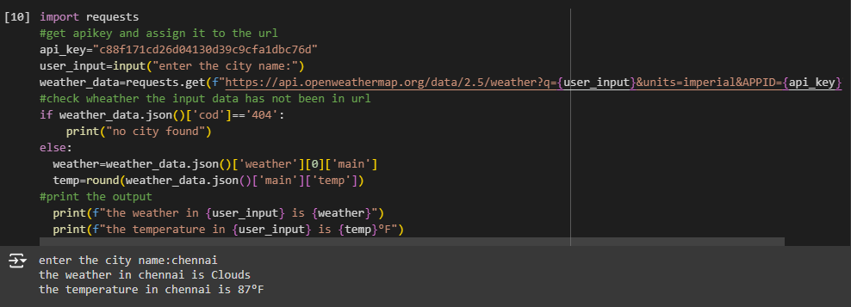

**Problem 2: Inventory Management System Optimization**

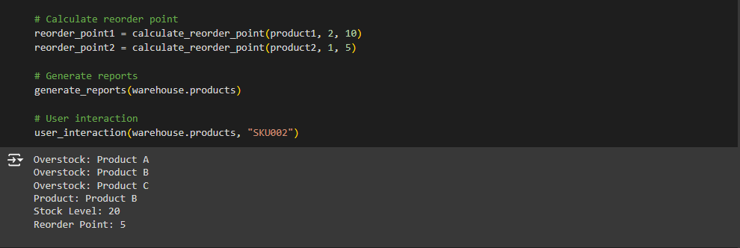

**Problem 4: Real-Time COVID-19 Statistics Tracker**

